Lucrarea de laborator nr. 6

Samciucov Valentin

Contoare

# Scopul lucrării:

1. Studierea experimentală a contorului numărării directe în regim static şi dinamic.
2. Studierea experimentală a contorului numărării inverse în regim static şi dinamic.
3. Studierea experimentală a contorului binar - zecimal în regim static şi dinamic.
4. Studierea experimentală a contorului după modulul M în regim static şi dinamic.

# Experimentul nr. 1. Contorul binar de ordinul şase al numărării directe

1. **Regim static.**

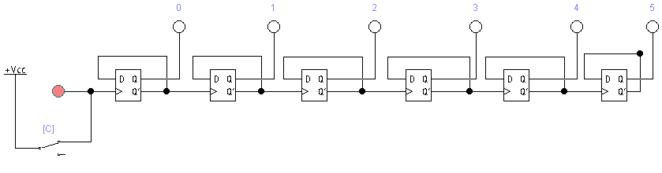

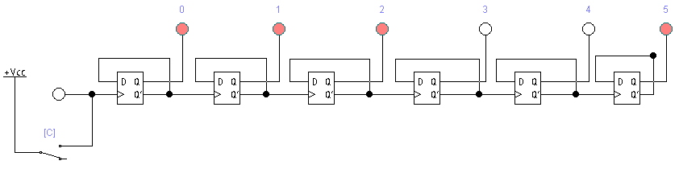

Fig. 1. Schema electrică a contorului binar de ordinul şase al numărării directe (regim static).

Tabelul 1. Stările contorului binar de ordinul şase al numărării directe

|  |  |  |  |  |  |  |
| --- | --- | --- | --- | --- | --- | --- |
| Nr. d/o | Q5 | Q4 | Q3 | Q2 | Q1 | Q0 |
| 0 | 0 | 0 | 0 | 0 | 0 | 0 |
| 1 | 1 | 0 | 0 | 0 | 0 | 0 |
| 2 | 0 | 1 | 0 | 0 | 0 | 0 |
| 3 | 1 | 1 | 0 | 0 | 0 | 0 |
| 4 | 0 | 0 | 1 | 0 | 0 | 0 |
| 5 | 1 | 0 | 1 | 0 | 0 | 0 |
| 6 | 0 | 1 | 1 | 0 | 0 | 0 |
| 7 | 1 | 1 | 1 | 0 | 0 | 0 |
| 8 | 0 | 0 | 0 | 1 | 0 | 0 |
| 9 | 1 | 0 | 0 | 1 | 0 | 0 |
| 10 | 0 | 1 | 0 | 1 | 0 | 0 |
| 11 | 1 | 1 | 0 | 1 | 0 | 0 |
| 12 | 0 | 0 | 1 | 1 | 0 | 0 |
| 13 | 1 | 0 | 1 | 1 | 0 | 0 |
| 14 | 0 | 1 | 1 | 1 | 0 | 0 |
| 15 | 1 | 1 | 1 | 1 | 0 | 0 |
| 16 | 0 | 0 | 0 | 0 | 1 | 0 |
| 17 | 1 | 0 | 0 | 0 | 1 | 0 |
| 18 | 0 | 1 | 0 | 0 | 1 | 0 |
| 19 | 1 | 1 | 0 | 0 | 1 | 0 |
| 20 | 0 | 0 | 1 | 0 | 1 | 0 |
| 21 | 1 | 0 | 1 | 0 | 1 | 0 |
| 22 | 0 | 1 | 1 | 0 | 1 | 0 |
| 23 | 1 | 1 | 1 | 0 | 1 | 0 |
| 24 | 0 | 0 | 0 | 1 | 1 | 0 |
| 25 | 1 | 0 | 0 | 1 | 1 | 0 |
| 26 | 0 | 1 | 0 | 1 | 1 | 0 |
| 27 | 1 | 1 | 0 | 1 | 1 | 0 |
| 28 | 0 | 0 | 1 | 1 | 1 | 0 |
| 29 | 1 | 0 | 1 | 1 | 1 | 0 |
| 30 | 0 | 1 | 1 | 1 | 1 | 0 |
| 31 | 1 | 1 | 1 | 1 | 1 | 0 |
| 32 | 0 | 0 | 0 | 0 | 0 | 1 |
| 33 | 1 | 0 | 0 | 0 | 0 | 1 |
| 34 | 0 | 1 | 0 | 0 | 0 | 1 |
| 35 | 1 | 1 | 0 | 0 | 0 | 1 |
| 36 | 0 | 0 | 1 | 0 | 0 | 1 |
| 37 | 1 | 0 | 1 | 0 | 0 | 1 |
| 38 | 0 | 1 | 1 | 0 | 0 | 1 |
| 39 | 1 | 1 | 1 | 0 | 0 | 1 |
| 40 | 0 | 0 | 0 | 1 | 0 | 1 |
| 41 | 1 | 0 | 0 | 1 | 0 | 1 |
| 42 | 0 | 1 | 0 | 1 | 0 | 1 |
| 43 | 1 | 1 | 0 | 1 | 0 | 1 |
| 44 | 0 | 0 | 1 | 1 | 0 | 1 |
| 45 | 1 | 0 | 1 | 1 | 0 | 1 |
| 46 | 0 | 1 | 1 | 1 | 0 | 1 |
| 47 | 1 | 1 | 1 | 1 | 0 | 1 |
| 48 | 0 | 0 | 0 | 0 | 1 | 1 |
| 49 | 1 | 0 | 0 | 0 | 1 | 1 |
| 50 | 0 | 1 | 0 | 0 | 1 | 1 |
| 51 | 1 | 1 | 0 | 0 | 1 | 1 |
| 52 | 0 | 0 | 1 | 0 | 1 | 1 |
| 53 | 1 | 0 | 1 | 0 | 1 | 1 |
| 54 | 0 | 1 | 1 | 0 | 1 | 1 |
| 55 | 1 | 1 | 1 | 0 | 1 | 1 |
| 56 | 0 | 0 | 0 | 1 | 1 | 1 |
| 57 | 1 | 0 | 0 | 1 | 1 | 1 |
| 58 | 0 | 1 | 0 | 1 | 1 | 1 |
| 59 | 1 | 1 | 0 | 1 | 1 | 1 |
| 60 | 0 | 0 | 1 | 1 | 1 | 1 |
| 61 | 1 | 0 | 1 | 1 | 1 | 1 |
| 62 | 0 | 1 | 1 | 1 | 1 | 1 |
| 63 | 1 | 1 | 1 | 1 | 1 | 1 |

1. **Regim dinamic.**

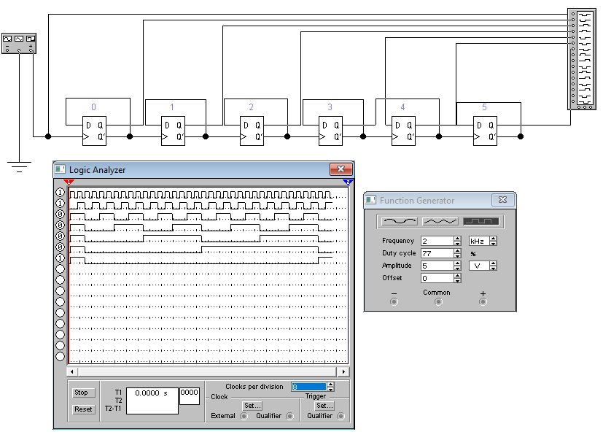

Fig. 2. Schema electrică a contorului binar de ordinul şase al numărării directe (regim dinamic).

Finit = 2000 Hz

F1 = 1000 Hz

F2 = 500 Hz

F3 = 250 Hz

F4 = 125 Hz

F5 = 62.5 Hz

F6 = 31.25 Hz

**Experimentul nr. 2. Contorul binar de ordinul şase al numărării inverse**

1. **Regim static.**

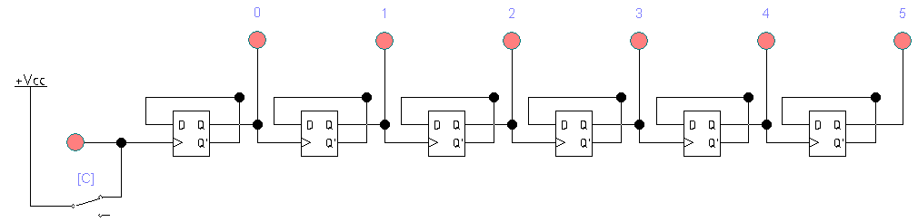

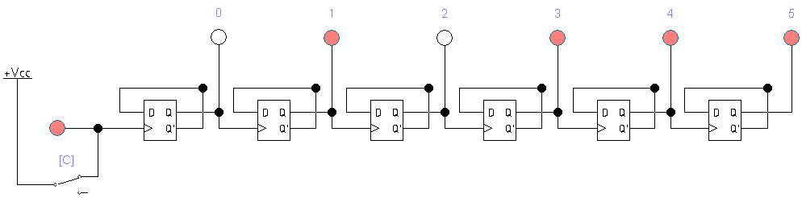

Fig. 3. Schema electrică a contorului binar de ordinul şase al numărării inverse (regim static).

Tabelul 2. Stările contorului binar de ordinul şase al numărării inverse

|  |  |  |  |  |  |  |
| --- | --- | --- | --- | --- | --- | --- |
| Nr. d/o | Q5 | Q4 | Q3 | Q2 | Q1 | Q0 |
| 0 | 1 | 1 | 1 | 1 | 1 | 1 |
| 1 | 0 | 1 | 1 | 1 | 1 | 1 |
| 2 | 1 | 0 | 1 | 1 | 1 | 1 |
| 3 | 0 | 0 | 1 | 1 | 1 | 1 |
| 4 | 1 | 1 | 0 | 1 | 1 | 1 |
| 5 | 0 | 1 | 0 | 1 | 1 | 1 |
| 6 | 1 | 0 | 0 | 1 | 1 | 1 |
| 7 | 0 | 0 | 0 | 1 | 1 | 1 |
| 8 | 1 | 1 | 1 | 0 | 1 | 1 |
| 9 | 0 | 1 | 1 | 0 | 1 | 1 |
| 10 | 1 | 0 | 1 | 0 | 1 | 1 |
| 11 | 0 | 0 | 1 | 0 | 1 | 1 |
| 12 | 1 | 1 | 0 | 0 | 1 | 1 |
| 13 | 0 | 1 | 0 | 0 | 1 | 1 |
| 14 | 1 | 0 | 0 | 0 | 1 | 1 |
| 15 | 0 | 0 | 0 | 0 | 1 | 1 |
| 16 | 1 | 1 | 1 | 1 | 0 | 1 |
| 17 | 0 | 1 | 1 | 1 | 0 | 1 |
| 18 | 1 | 0 | 1 | 1 | 0 | 1 |
| 19 | 0 | 0 | 1 | 1 | 0 | 1 |
| 20 | 1 | 1 | 0 | 1 | 0 | 1 |
| 21 | 0 | 1 | 0 | 1 | 0 | 1 |
| 22 | 1 | 0 | 0 | 1 | 0 | 1 |
| 23 | 0 | 0 | 0 | 1 | 0 | 1 |
| 24 | 1 | 1 | 1 | 0 | 0 | 1 |
| 25 | 0 | 1 | 1 | 0 | 0 | 1 |
| 26 | 1 | 0 | 1 | 0 | 0 | 1 |
| 27 | 0 | 0 | 1 | 0 | 0 | 1 |
| 28 | 1 | 1 | 0 | 0 | 0 | 1 |
| 29 | 0 | 1 | 0 | 0 | 0 | 1 |
| 30 | 1 | 0 | 0 | 0 | 0 | 1 |
| 31 | 0 | 0 | 0 | 0 | 0 | 1 |
| 32 | 1 | 1 | 1 | 1 | 1 | 0 |
| 33 | 0 | 1 | 1 | 1 | 1 | 0 |
| 34 | 1 | 0 | 1 | 1 | 1 | 0 |
| 35 | 0 | 0 | 1 | 1 | 1 | 0 |
| 36 | 1 | 1 | 0 | 1 | 1 | 0 |
| 37 | 0 | 1 | 0 | 1 | 1 | 0 |
| 38 | 1 | 0 | 0 | 1 | 1 | 0 |
| 39 | 0 | 0 | 0 | 1 | 1 | 0 |
| 40 | 1 | 1 | 1 | 0 | 1 | 0 |
| 41 | 0 | 1 | 1 | 0 | 1 | 0 |
| 42 | 1 | 0 | 1 | 0 | 1 | 0 |
| 43 | 0 | 0 | 1 | 0 | 1 | 0 |
| 44 | 1 | 1 | 0 | 0 | 1 | 0 |
| 45 | 0 | 1 | 0 | 0 | 1 | 0 |
| 46 | 1 | 0 | 0 | 0 | 1 | 0 |
| 47 | 0 | 0 | 0 | 0 | 1 | 0 |
| 48 | 1 | 1 | 1 | 1 | 0 | 0 |
| 49 | 0 | 1 | 1 | 1 | 0 | 0 |
| 50 | 1 | 0 | 1 | 1 | 0 | 0 |
| 51 | 0 | 0 | 1 | 1 | 0 | 0 |
| 52 | 1 | 1 | 0 | 1 | 0 | 0 |
| 53 | 0 | 1 | 0 | 1 | 0 | 0 |
| 54 | 1 | 0 | 0 | 1 | 0 | 0 |
| 55 | 0 | 0 | 0 | 1 | 0 | 0 |
| 56 | 1 | 1 | 1 | 0 | 0 | 0 |
| 57 | 0 | 1 | 1 | 0 | 0 | 0 |
| 58 | 1 | 0 | 1 | 0 | 0 | 0 |
| 59 | 0 | 0 | 1 | 0 | 0 | 0 |
| 60 | 1 | 1 | 0 | 0 | 0 | 0 |
| 61 | 0 | 1 | 0 | 0 | 0 | 0 |
| 62 | 1 | 0 | 0 | 0 | 0 | 0 |
| 63 | 0 | 0 | 0 | 0 | 0 | 0 |

1. **Regim dinamic.**

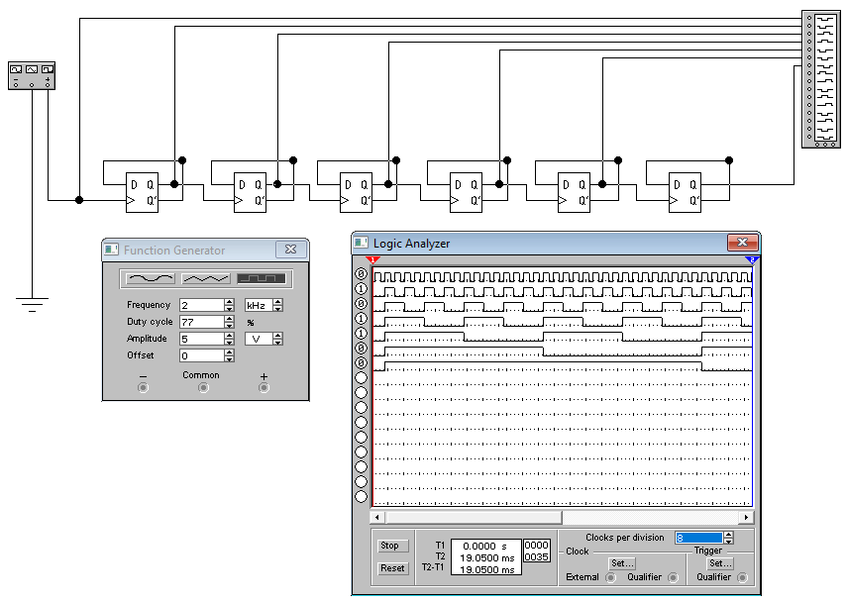

Fig. 4. Schema electrică a contorului binar de ordinul şase al numărării inverse (regim dinamic).

Finit = 2000 Hz

F1 = 1000 Hz

F2 = 500 Hz

F3 = 250 Hz

F4 = 125 Hz

F5 = 62.5 Hz

F6 = 31.25 Hz

**Experimentul nr. 3. Contorul binar-zecimal**

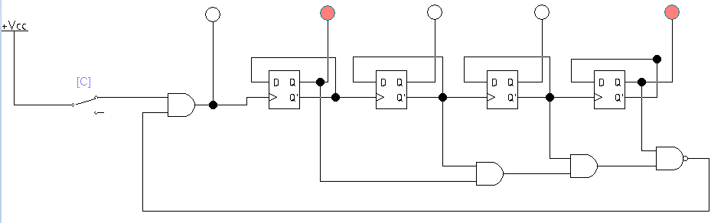

Fig. 5. Schema electrică a contorului binar – zecimal.

Tabelul 3. Stările contorului binar – zecimal

|  |  |  |  |  |  |
| --- | --- | --- | --- | --- | --- |
| Nr. d/o | C | Q3 | Q2 | Q1 | Q0 |
| 0 |  | 0 | 0 | 0 | 0 |
| 1 |  | 1 | 0 | 0 | 0 |
| 2 |  | 0 | 1 | 0 | 0 |
| 3 |  | 1 | 1 | 0 | 0 |
| 4 |  | 0 | 0 | 1 | 0 |
| 5 |  | 1 | 0 | 1 | 0 |
| 6 |  | 0 | 1 | 1 | 0 |
| 7 |  | 1 | 1 | 1 | 0 |
| 8 |  | 0 | 0 | 0 | 1 |
| 9 |  | 1 | 0 | 0 | 1 |

**Experimentul nr. 4. Contorul binar după modulul M**

Tabelul 4. Modulul M

|  |  |
| --- | --- |
| Nr. d/o | Modulul M |
| 17. | 110011 |

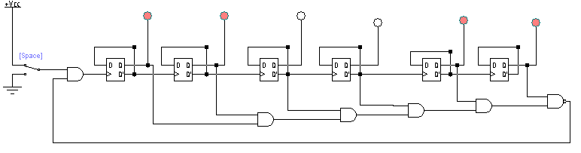

Fig. 6. Schema electrica a contorului binar dupa modulul M.

Tabelul 5. Stările contorului binar după modulul M

|  |  |  |  |  |  |  |
| --- | --- | --- | --- | --- | --- | --- |
| Nr. d/o | Q5 | Q4 | Q3 | Q2 | Q1 | Q0 |
| 0. | 0 | 0 | 0 | 0 | 0 | 0 |
| 1. | 1 | 0 | 0 | 0 | 0 | 0 |
| 2. | 0 | 1 | 0 | 0 | 0 | 0 |
| 3. | 1 | 1 | 0 | 0 | 0 | 0 |
| 4. | 0 | 0 | 1 | 0 | 0 | 0 |
| 5. | 1 | 0 | 1 | 0 | 0 | 0 |
| 6. | 0 | 1 | 1 | 0 | 0 | 0 |
| 7. | 1 | 1 | 1 | 0 | 0 | 0 |
| 8. | 0 | 0 | 0 | 1 | 0 | 0 |
| 9. | 1 | 0 | 0 | 1 | 0 | 0 |
| 10. | 0 | 1 | 0 | 1 | 0 | 0 |
| 11. | 1 | 1 | 0 | 1 | 0 | 0 |
| 12. | 0 | 0 | 1 | 1 | 0 | 0 |
| 13. | 1 | 0 | 1 | 1 | 0 | 0 |
| 14. | 0 | 1 | 1 | 1 | 0 | 0 |
| 15. | 1 | 1 | 1 | 1 | 0 | 0 |
| 16. | 0 | 0 | 0 | 0 | 1 | 0 |
| 17. | 1 | 0 | 0 | 0 | 1 | 0 |
| 18. | 0 | 1 | 0 | 0 | 1 | 0 |
| 19. | 1 | 1 | 0 | 0 | 1 | 0 |
| 20. | 0 | 0 | 1 | 0 | 1 | 0 |
| 21. | 1 | 0 | 1 | 0 | 1 | 0 |
| 22. | 0 | 1 | 1 | 0 | 0 | 0 |
| 23. | 1 | 1 | 1 | 0 | 1 | 0 |
| 24. | 0 | 0 | 0 | 1 | 1 | 0 |
| 25. | 1 | 0 | 0 | 1 | 1 | 0 |
| 26. | 0 | 1 | 0 | 1 | 1 | 0 |
| 27. | 1 | 1 | 0 | 1 | 1 | 0 |
| 28. | 0 | 0 | 1 | 1 | 1 | 0 |
| 29. | 1 | 0 | 1 | 1 | 1 | 0 |
| 30. | 0 | 1 | 1 | 1 | 1 | 0 |
| 31. | 1 | 1 | 1 | 1 | 1 | 0 |
| 32. | 0 | 0 | 0 | 0 | 0 | 1 |
| 33. | 1 | 0 | 0 | 0 | 0 | 1 |
| 34. | 0 | 1 | 0 | 0 | 0 | 1 |
| 35. | 1 | 1 | 0 | 0 | 0 | 1 |
| 36. | 0 | 0 | 1 | 0 | 0 | 1 |
| 37. | 1 | 0 | 1 | 0 | 0 | 1 |
| 38. | 0 | 1 | 1 | 0 | 0 | 1 |
| 39. | 1 | 1 | 1 | 0 | 0 | 1 |
| 40. | 0 | 0 | 0 | 1 | 0 | 1 |
| 41. | 1 | 0 | 0 | 1 | 0 | 1 |
| 42. | 0 | 1 | 0 | 1 | 0 | 1 |
| 43. | 1 | 1 | 0 | 1 | 0 | 1 |
| 44. | 0 | 0 | 1 | 1 | 0 | 1 |
| 45. | 1 | 0 | 1 | 1 | 0 | 1 |
| 46. | 0 | 1 | 1 | 1 | 0 | 1 |
| 47. | 1 | 1 | 1 | 1 | 0 | 1 |
| 48. | 0 | 0 | 0 | 0 | 1 | 1 |
| 49. | 1 | 0 | 0 | 0 | 1 | 1 |
| 50. | 0 | 1 | 0 | 0 | 1 | 1 |
| 51. | 1 | 1 | 0 | 0 | 1 | 1 |

**Experimentul nr. 5. Contorul binar cu repetarea ciclului de numărare**

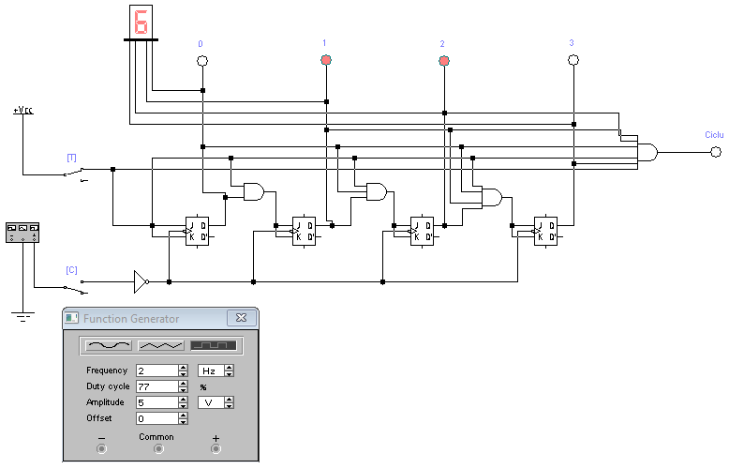

Fig. 7. Schema electrică a contorului binar cu repetarea ciclului de numerare.

Tabelul 6. Stările contorului binar cu repetarea ciclului de numerare

|  |  |  |  |  |  |  |
| --- | --- | --- | --- | --- | --- | --- |
| Nr. d/o | C | Q3 | Q2 | Q1 | Q0 | Numar hexazecimal |
| 0 | ↑ | 0 | 0 | 0 | 0 | 0 |
| 1 | ↑ | 1 | 0 | 0 | 0 | 1 |
| 2 | ↑ | 0 | 1 | 0 | 0 | 2 |
| 3 | ↑ | 1 | 1 | 0 | 0 | 3 |
| 4 | ↑ | 0 | 0 | 1 | 0 | 4 |
| 5 | ↑ | 1 | 0 | 1 | 0 | 5 |
| 6 | ↑ | 0 | 1 | 1 | 0 | 6 |
| 7 | ↑ | 1 | 1 | 1 | 0 | 7 |
| 8 | ↑ | 0 | 0 | 0 | 1 | 8 |
| 9 | ↑ | 1 | 0 | 0 | 1 | 9 |
| 10 | ↑ | 0 | 1 | 0 | 1 | A |
| 11 | ↑ | 1 | 1 | 0 | 1 | B |
| 12 | ↑ | 0 | 0 | 1 | 1 | C |
| 13 | ↑ | 1 | 0 | 1 | 1 | D |
| 14 | ↑ | 0 | 1 | 1 | 1 | E |
| 15 | ↑ | 1 | 1 | 1 | 1 | F |